BIA4100: Location Analytics

Project 2: Rural Tennessee

Task 1: Town Selection - Sevierville, Tennessee

**Introduction:**

**For Project:** Rural Tennessee, I have selected the town of Sevierville, Tennessee, as the focus of my analysis. Sevierville offers a unique blend of factors that make it an ideal choice for this project:

**Population:** With a population of approximately 17,987 residents, Sevierville falls within the desired range of 5,000 and 50,000, making it representative of a small rural town.

**Diverse Landscape:** Situated near the Great Smoky Mountains National Park, Sevierville is susceptible to various natural disasters, including landslides, wildfires, and floods. This diversity provides ample data for analysis and understanding disaster preparedness in different contexts.

**Data Accessibility:** The availability of data for Sevierville is good, with resources available from FEMA, the US Census Bureau, the USGA, and other government agencies. This allows for a comprehensive assessment of the town's vulnerabilities and preparedness.

**Tourism Significance:** Sevierville boasts a thriving tourism industry, making it a vital economic hub for the region. Understanding disaster preparedness in this context becomes crucial for ensuring the safety of residents and tourists alike.

**Exploration:**

To further explore Sevierville, I have utilized Google Maps to familiarize myself with the town's layout, key features, and surrounding areas. This preliminary research helps identify potential areas of focus and data needs for the project.

Task 2: Establishing the Development Process for a Disaster Response Map for Sevierville, Tennessee

Having gathered data from various sources including FEMA Floodplain Maps, US Census data, USGA data, and the location of the Sevier County Emergency Management agency, I will now establish a clear development process for the disaster response map of Sevierville, Tennessee.

**Key Questions:**

Based on the available data and the specific context of Sevierville, the following key questions will guide the development of the map:

1. Where are the areas most susceptible to flooding?
2. How are different population groups distributed across the town?
3. Where are the critical infrastructure facilities located?
4. What emergency response resources are available in Sevierville?

**Data Mapping:**

Each of these questions can be answered by mapping the relevant data sources:

|  |  |  |
| --- | --- | --- |
| **Question** | **Data Source Name** | **Link** |
| 1. Flood Susceptibility | FEMA Floodplain Maps | <https://msc.fema.gov/portal/search?AddressQuery=Sevierville> |
| 2. Landslide and Wildfire Risk | USGA data (topography, land cover, soil type) | <https://waterdata.usgs.gov/monitoring-location/03470000/#parameterCode=00065&period=P30D&showMedian=true> |
| 3. Population Distribution | US Census data (demographics, income, housing) | <https://www.census.gov/quickfacts/seviervillecitytennessee> |
| 4. Critical Infrastructure Locations | Open-source data or official Sevierville resources |  |
| 5. Emergency Response Resources | Sevier County Emergency Management website | <https://www.seviercountytn.gov/government/departments/emergency/emergency_management_agency.php> |

**Assumptions:**

**Data Accuracy and Completeness:** The accuracy and completeness of the datasets used (FEMA Floodplain Map, US Census data, USGA data, etc.) are accurate and reliable.

**Data Compatibility:** The datasets can be easily converted to compatible formats and integrated within QGIS for analysis.

**Data Representativeness:** The datasets accurately represent current conditions and trends in Sevierville.

**Chosen Methods:** The chosen methods for data analysis, visualization, and map creation are appropriate and effective for the project goals.

**Symbology and Labeling Choices:** The chosen symbology and labeling effectively represent the data and are clear and understandable for users.

**Spatial Analysis Techniques:** The chosen spatial analysis techniques are appropriate for identifying vulnerable areas and potential risk hotspots.

Task 3: Importing the data as layers and formatting to create a flood disaster map for Sevierville

**Datasets Used:** I used the datasets from FEMA flood hazard maps, US Census data to locate population, demographic and housing areas and USGA dataset to find relevant layers such as topography and cover areas.

Step 1:

Took a basic map of Sevierville town and started creating layers on it for relevant data.

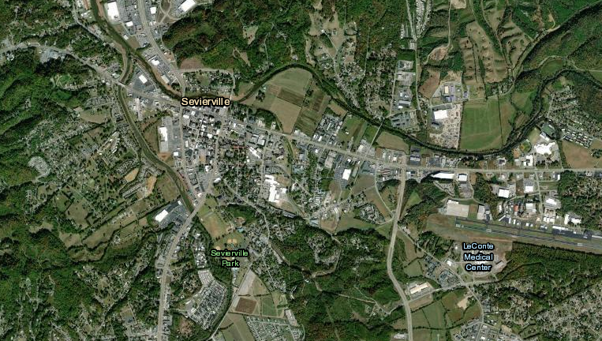

Step 2:

Imported a vector layer to find GIS links along the areas around the Sevierville to define the boundary and study area.

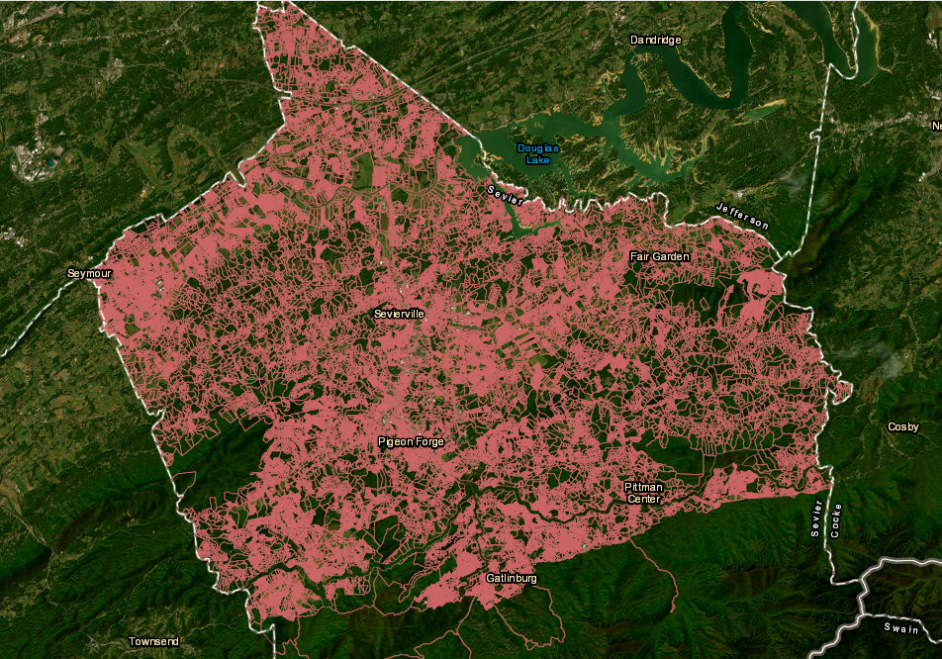

Step 3:

Imported a vector layer to show Flood way in blue color using FEMA dataset on the website to show the way of flood towards the prone areas.

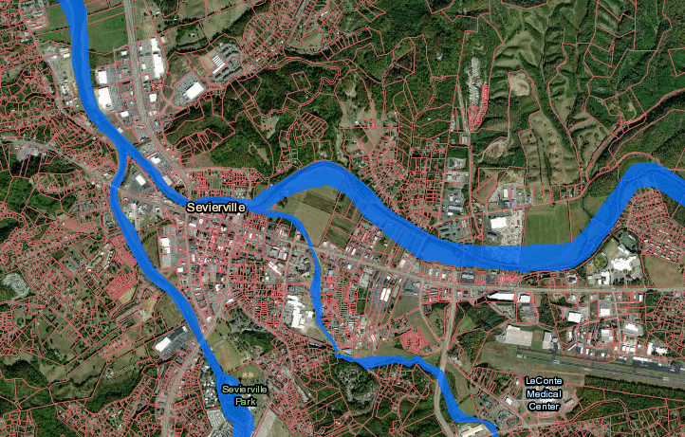

Step 4:

Inserted flood categories (Red, Pink, Dark Blue) to show the areas that can be affected badly and have a high chance of flooding around the water areas. This data is based on the US Census dataset.

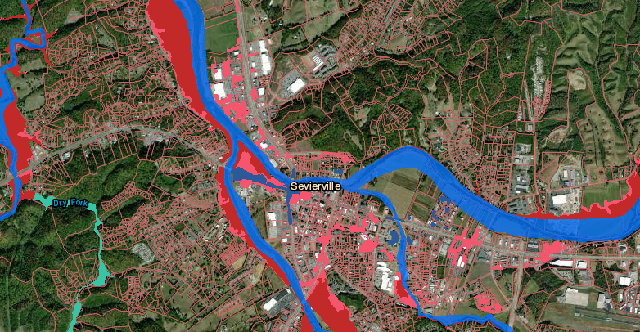

Step 5:

Imported a vector layer in Orange color to show Flood data of the affected areas over the last 100 years in the way of water flowing.

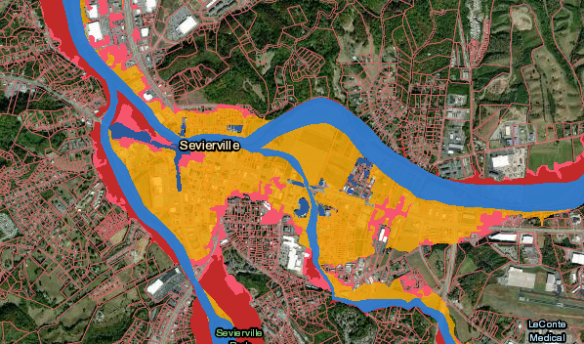

Step 6:

Imported a vector layer to show city limits in already created flood disaster map to show the city boundaries.

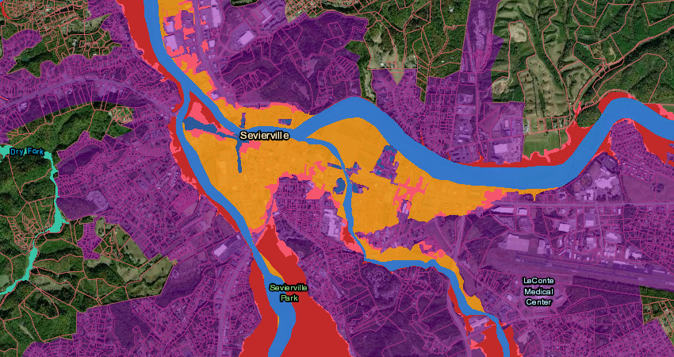

Categories Used:  
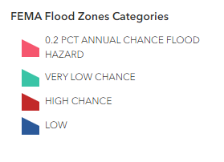

Layers Used:

**Discussion (Write Up):**This map serves as a comprehensive guide to flood risk in Sevierville, Tennessee. By visualizing flood potential through four distinct flood zones, it empowers residents and authorities to understand their vulnerability and prepare effectively.

This color-coded visualization was chosen for its intuitive nature and accessibility. The gradual progression from light blue (low risk) to deep red (high risk) immediately conveys the severity of flooding in different areas. This format is familiar and easily digestible for diverse audiences, fostering widespread awareness and understanding.

Symbols and glyphs amplify the map's effectiveness by adding layers of information without cluttering the visual space. Floodplain boundaries are clearly defined, while strategic infrastructure like hospitals and shelters are highlighted with distinct icons. This ensures residents can readily identify critical resources during emergencies.

Moreover, the map incorporates subtle details to enhance its informative value. Gradient shading within each zone indicates the varying degrees of risk within each category. This nuanced approach allows for targeted preparedness measures, enabling residents to tailor their actions to the specific threat level of their area.

In conclusion, this map leverages color, symbols, and nuanced details to create a clear and actionable visualization of Sevierville's flood risk. By prioritizing accessibility and detail, this map empowers residents and authorities alike to navigate the potentially devastating realities of flood events and work towards a more resilient future.

**Final Map**

